UI&UX Analysis

GD08 Cloud

*Bad UX design: Elden Ring*

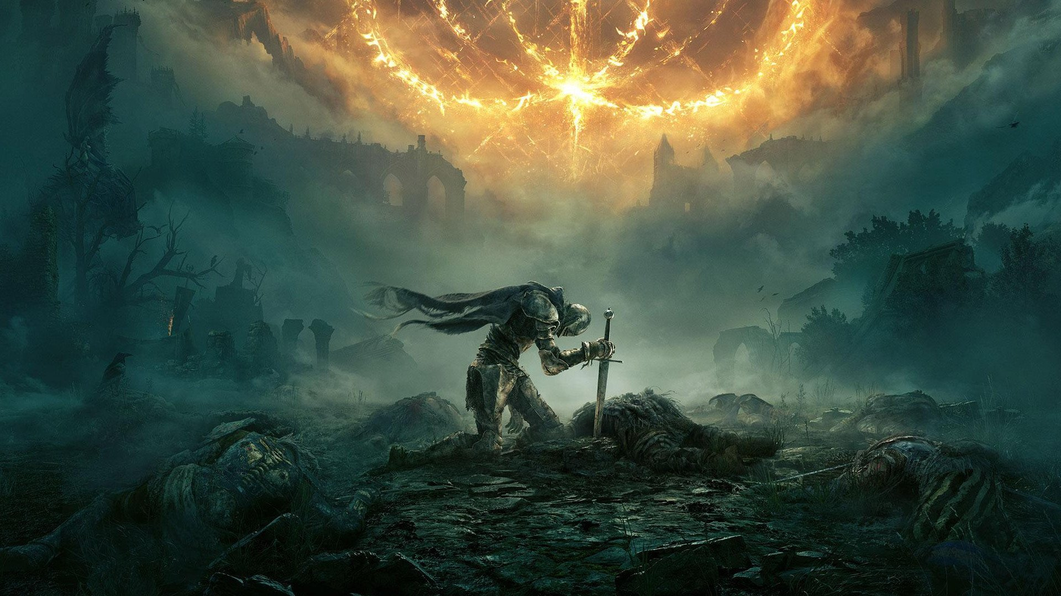

Figure 0

# Overview

* Lack enough explanation
* Non-intuitive menu distribution
* Unreasonable user flow
* Be friendly to soul-like game players but very bad to new players

# Lack Enough Explanation

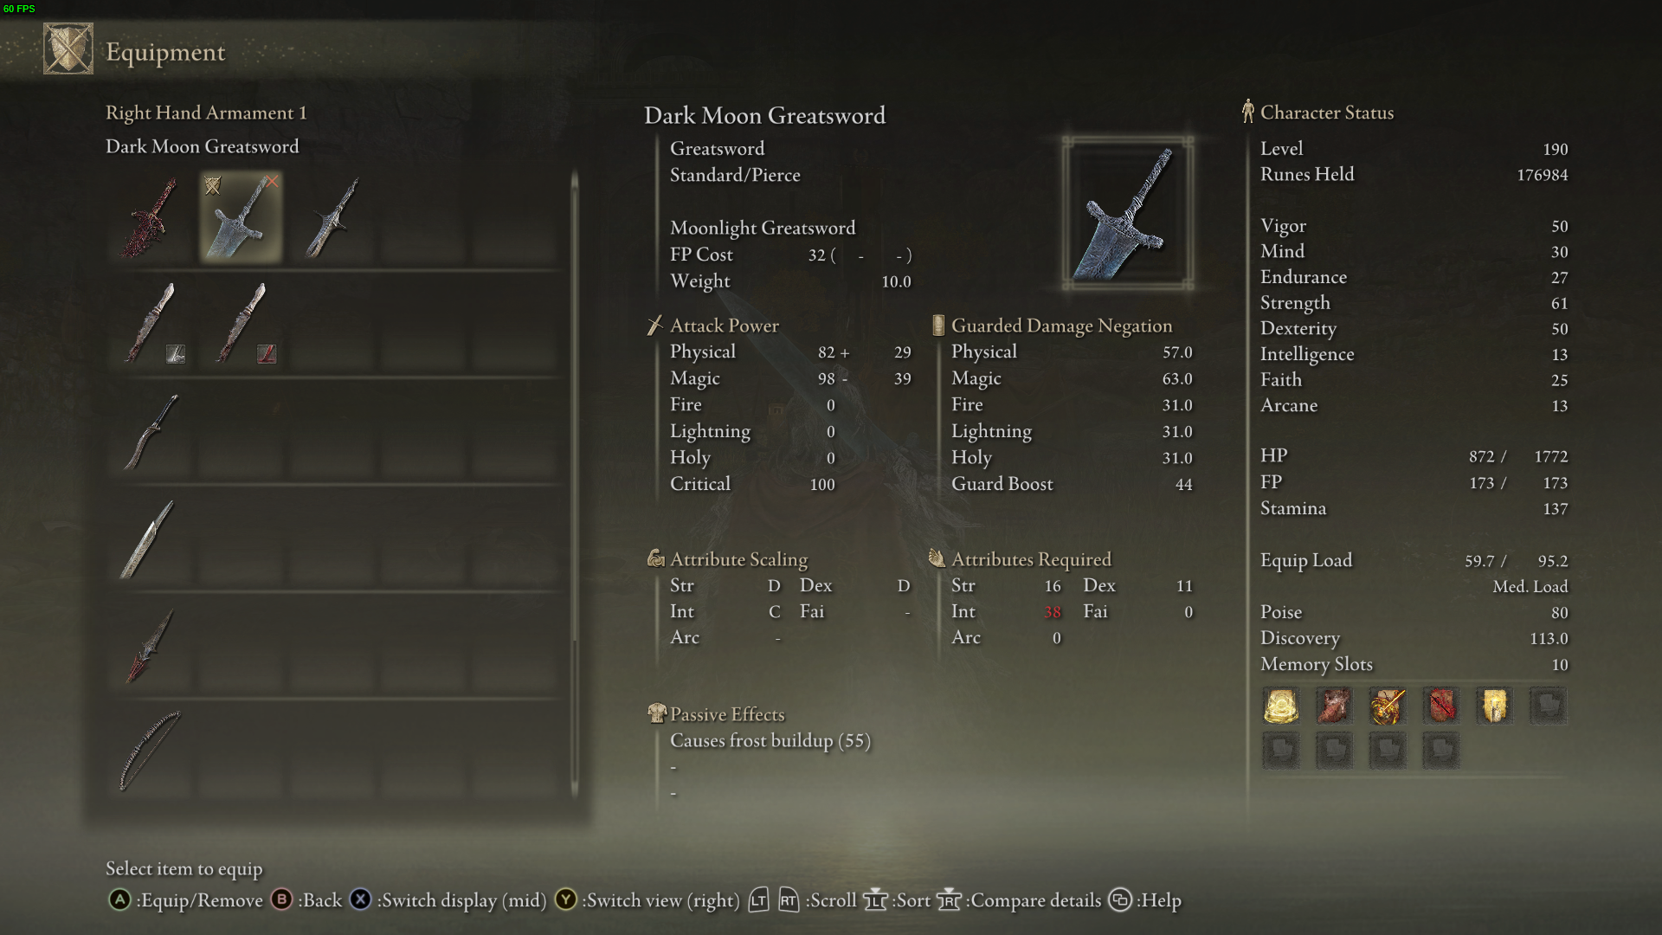

Figure

* ‘Attribute Scaling’ uses letters ‘S’ to ‘E’ to show the how big the ‘Character Status’ will influence the ‘Attack Power’, but it’s too incomprehensible.
* As a new gamer who hasn’t played soul-like games before, he will find it really difficult to understand the difference between letter ‘D’ and ‘C’, and he will also meet problem when finding symbols ‘+’ and ‘-’ in ‘Attack Power’.

# Non-intuitive Menu Distribution

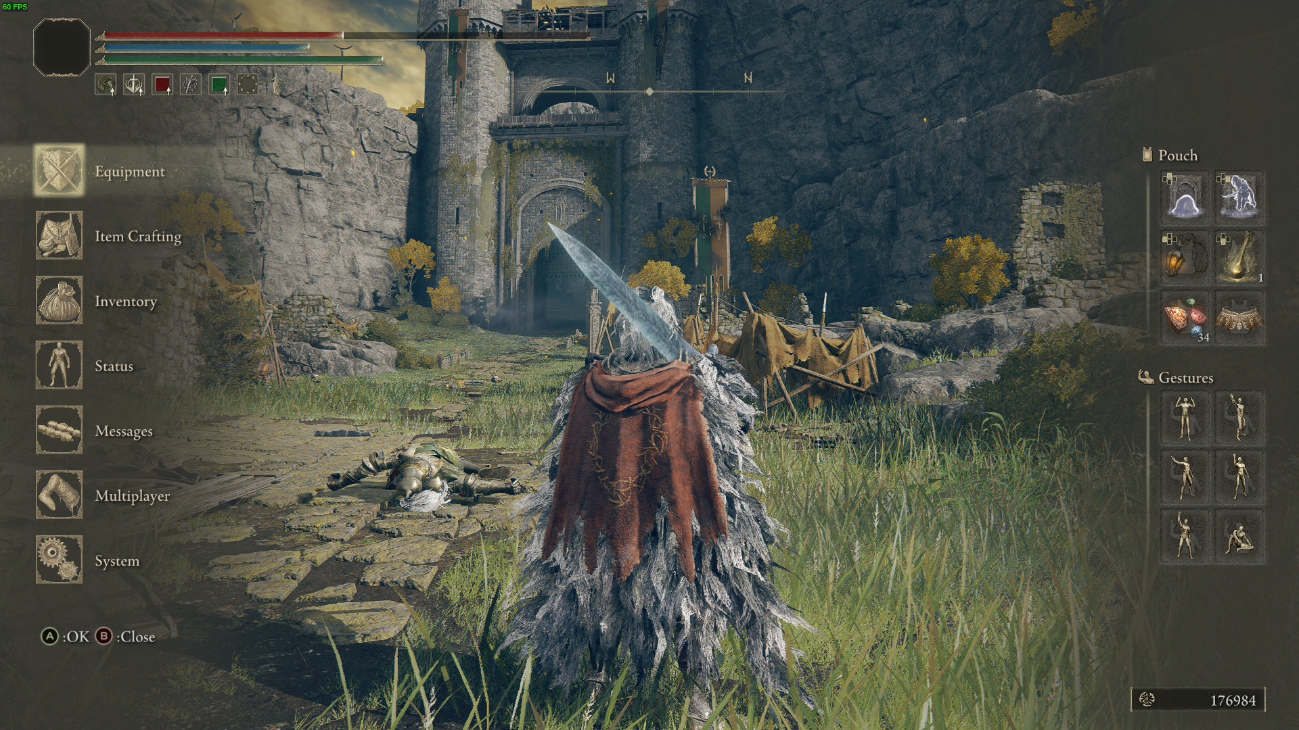

Figure

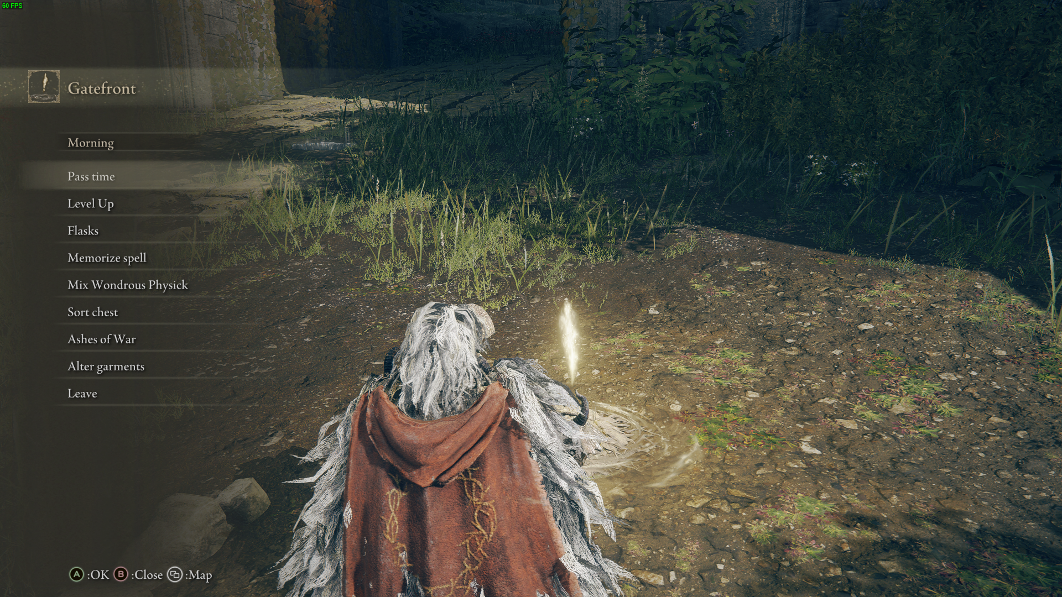

Figure

* After over 100 hours’ of playing, I just started to have a little bit understanding and adapt to why Elden Ring put so many stuff and function in different places. But as new players, it is very non-intuitive.
* As figure 3 shows, the game puts many very important functions and menus in the sites of grace. But most players just see sites of grace as a place to heal and refresh monsters and usually ignore the menu here, this causes that new players often meet questions like ‘I can’t find xxx’ in the beginning.

# Unreasonable User Flow

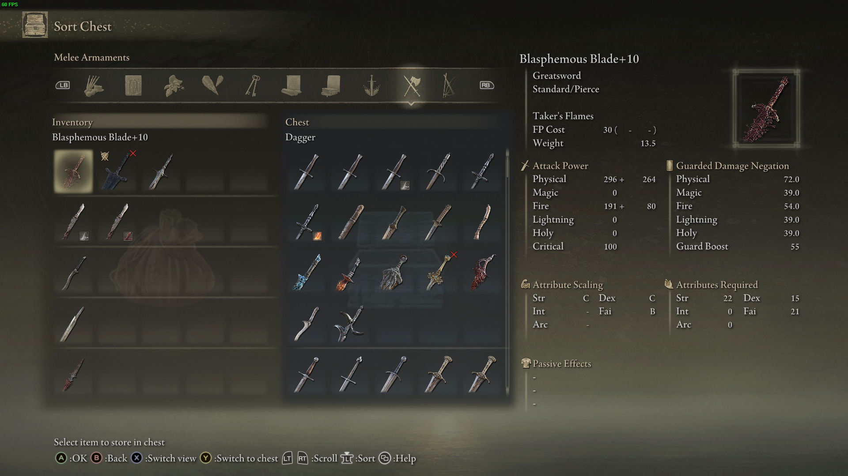

Figure

* The most frequently used menu (weapons and suits) is put the farthest place from player —— the middle of all sub menus. (Figure 4)

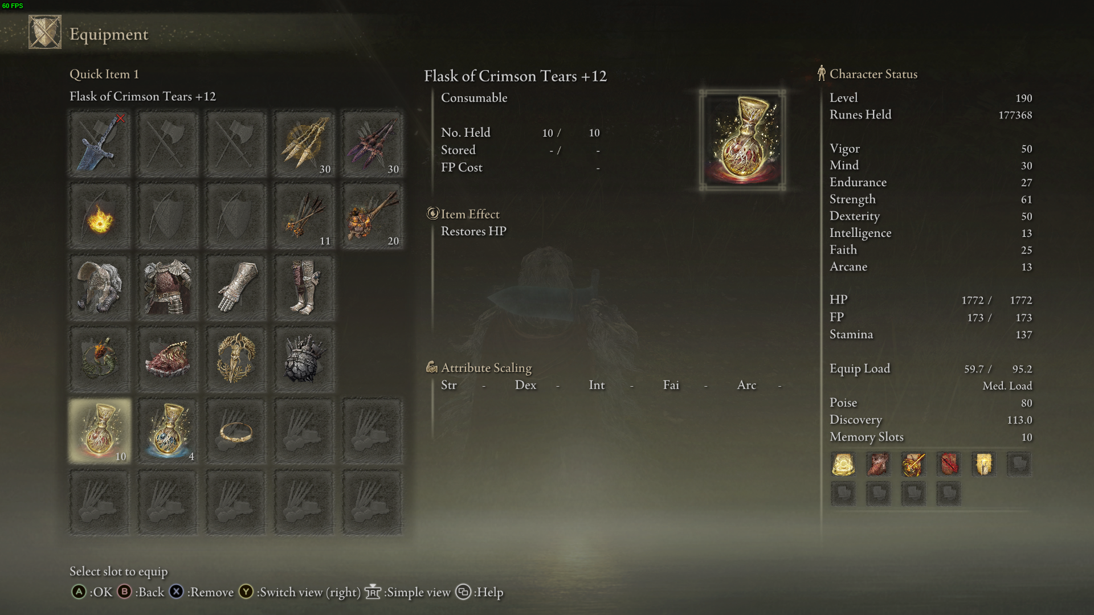

Figure

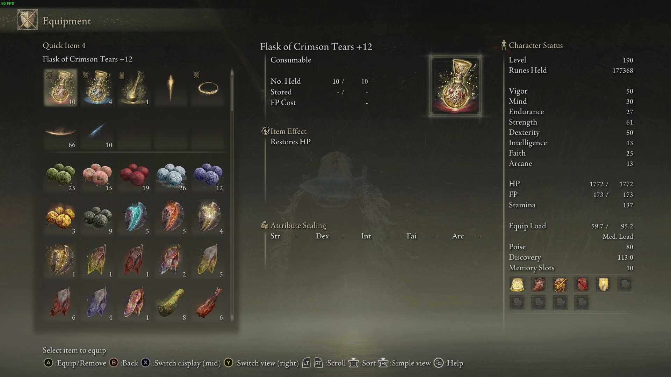

Figure

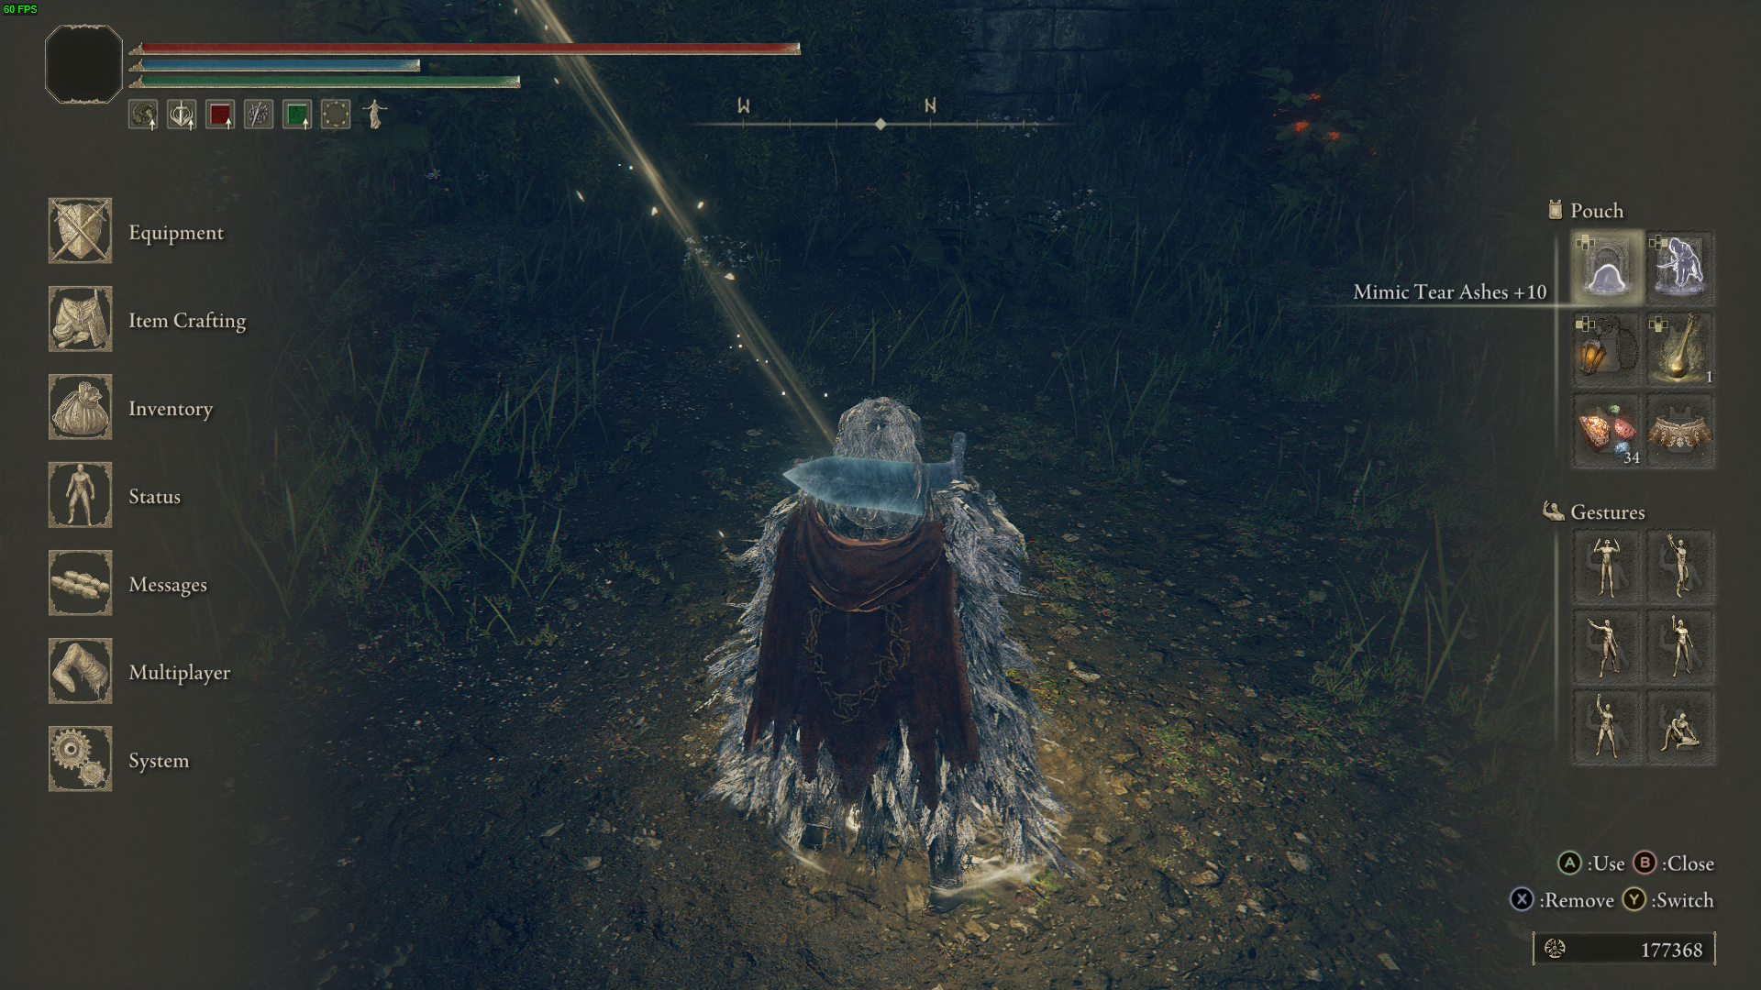

Figure

* The game uses two different strange ways to arrange two pouches. VERY STRANGE. Pouch 1 is in the lower left corner of the equipment bar, click the blank then choose your prop (Figure 5&6), but Pouch 2 is in the upper right corner of main menu (Figure 7).

# Conclusion

* After investigation, I find for those players who have played soul games before tend to be very familiar with Elden Ring’s UI and can totally understand almost everything in the menu when entering the game for the first time. But for those rookies, this kind of menu will be a disaster and will take them huge time to understand without other experienced players’ explanation.

*Good UX design: Slay The Spire*

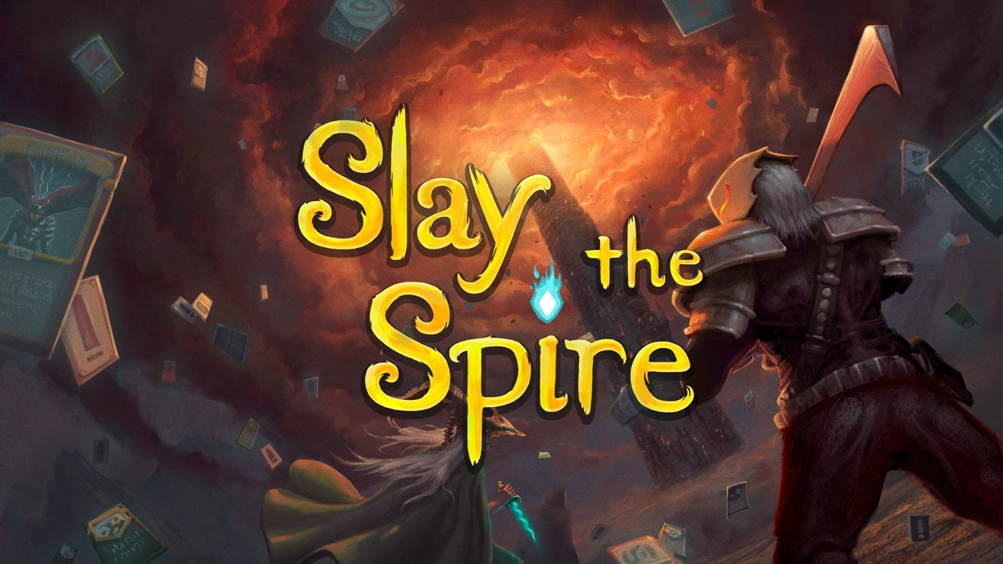

Figure

# Overview

* Neat, clear and concise UI icons and layout
* Easy access to know more about almost everything you want to know in the game
* Personalization

# Neat UI Layout

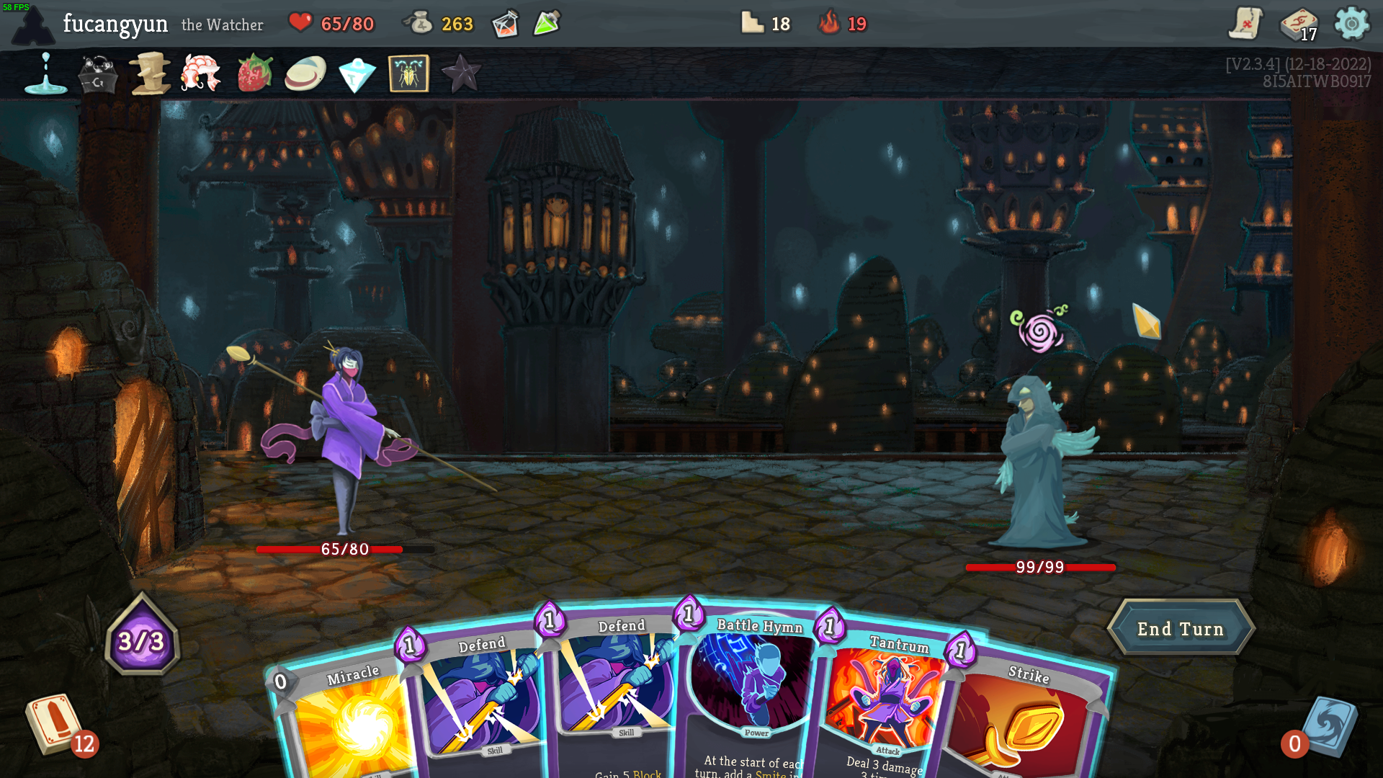

Figure

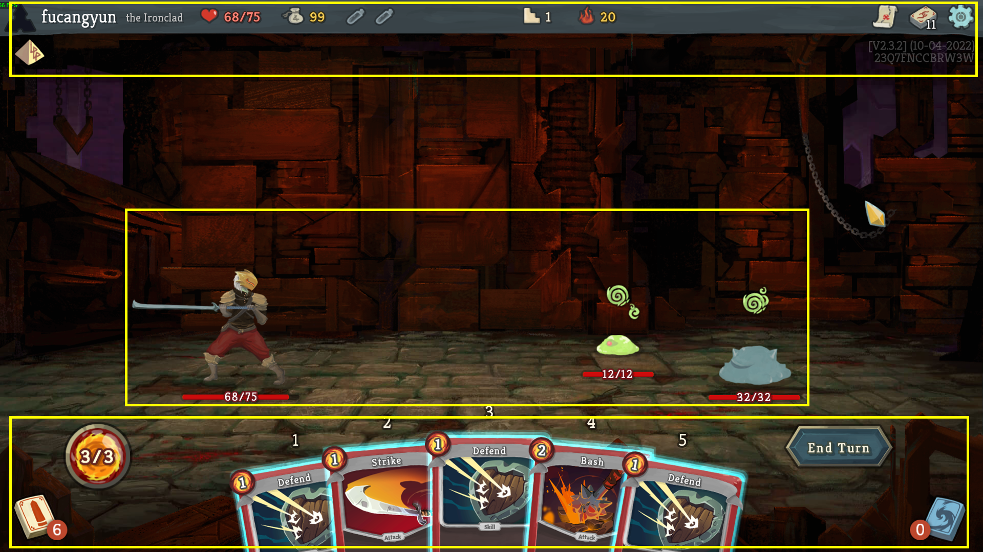

Figure

* UI in fight sticks out a mile. Hand cards, battlefield, props bar have a clear division of labor and also do a great cooperation. (Figure 9&10)

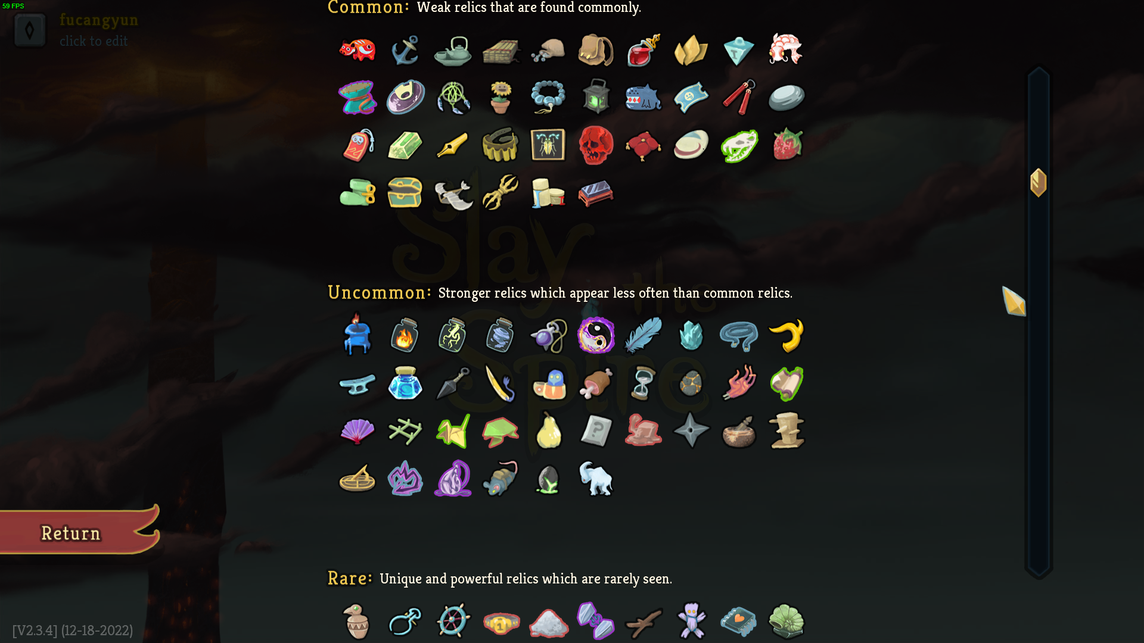

Figure

* When talking about icons, it’s more about whether all icons’ art style fit well and whether these icons have enough identification to convey their information. It’s hard to fully prove it by a few pictures, but for me, the answer to former two questions is YES. (Figure 11)

# Easy Access to Know Everything

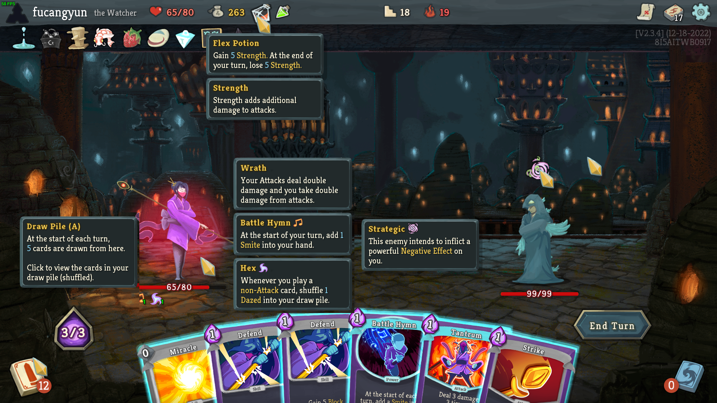

Figure

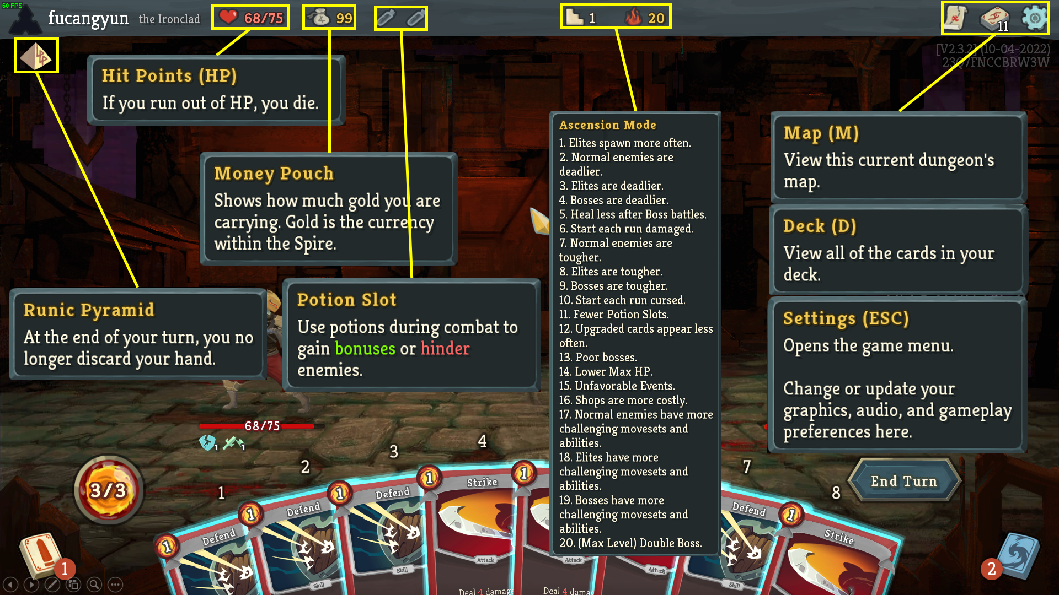

Figure

* If you have anything hard to understand, just move your cursor onto it and see the note, no matter key words or just a sub-menu. (Figure 12 is like an in-game screenshot and Figure 13 is artificial)

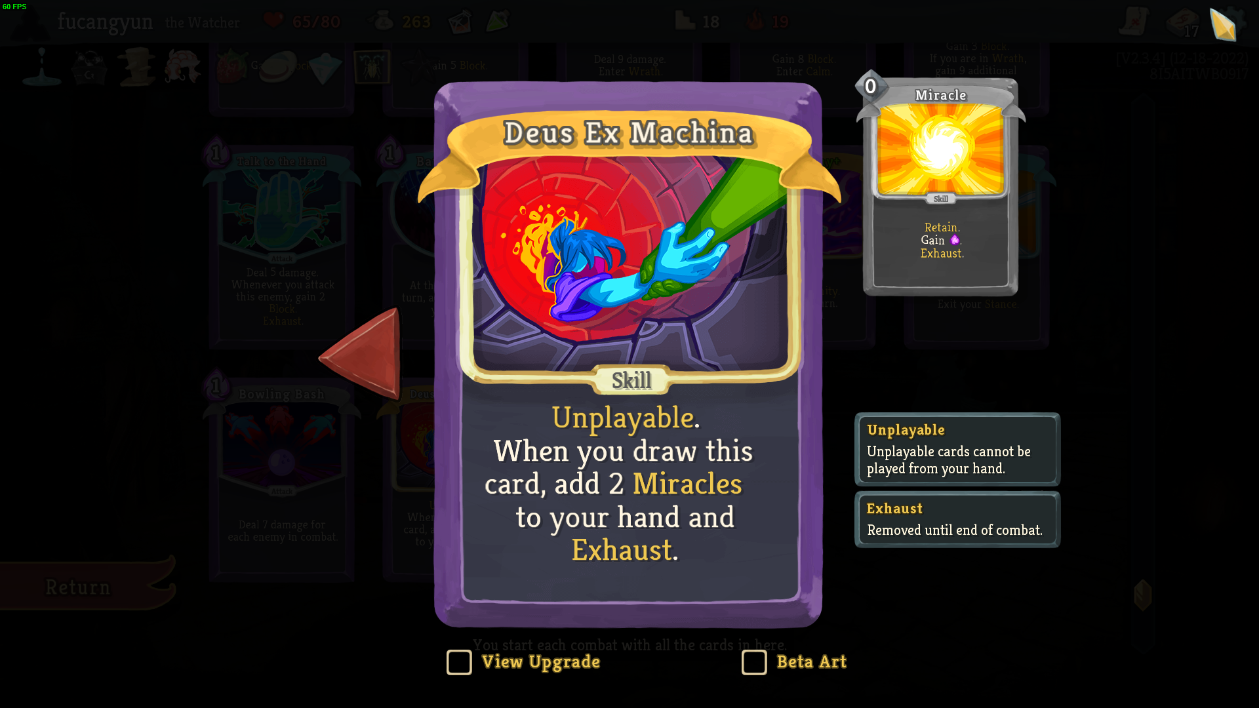

Figure

* If you feel the letters on cards are too small or just want another place instead of battlefield to know details, you can click on corresponding menu to get a clearer looking. (Figure 14)

# Personalization

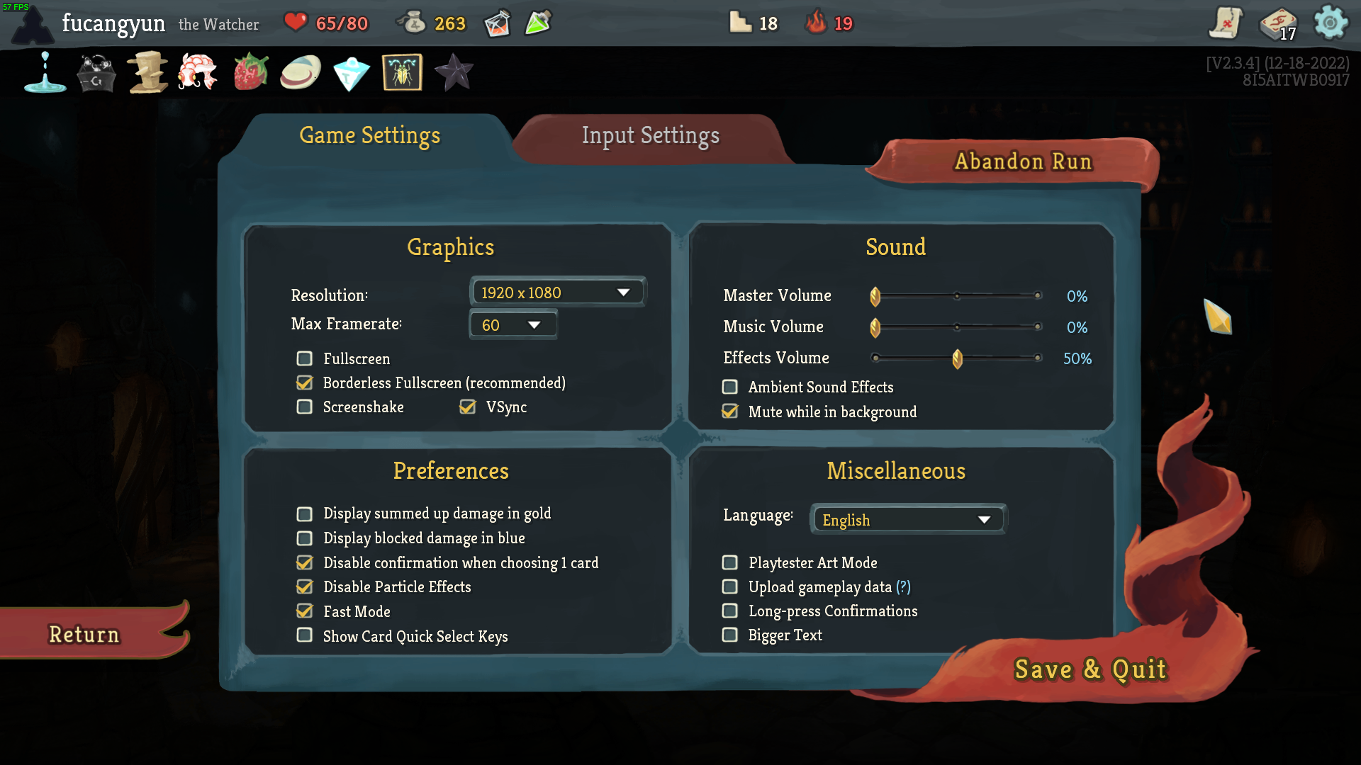

Figure

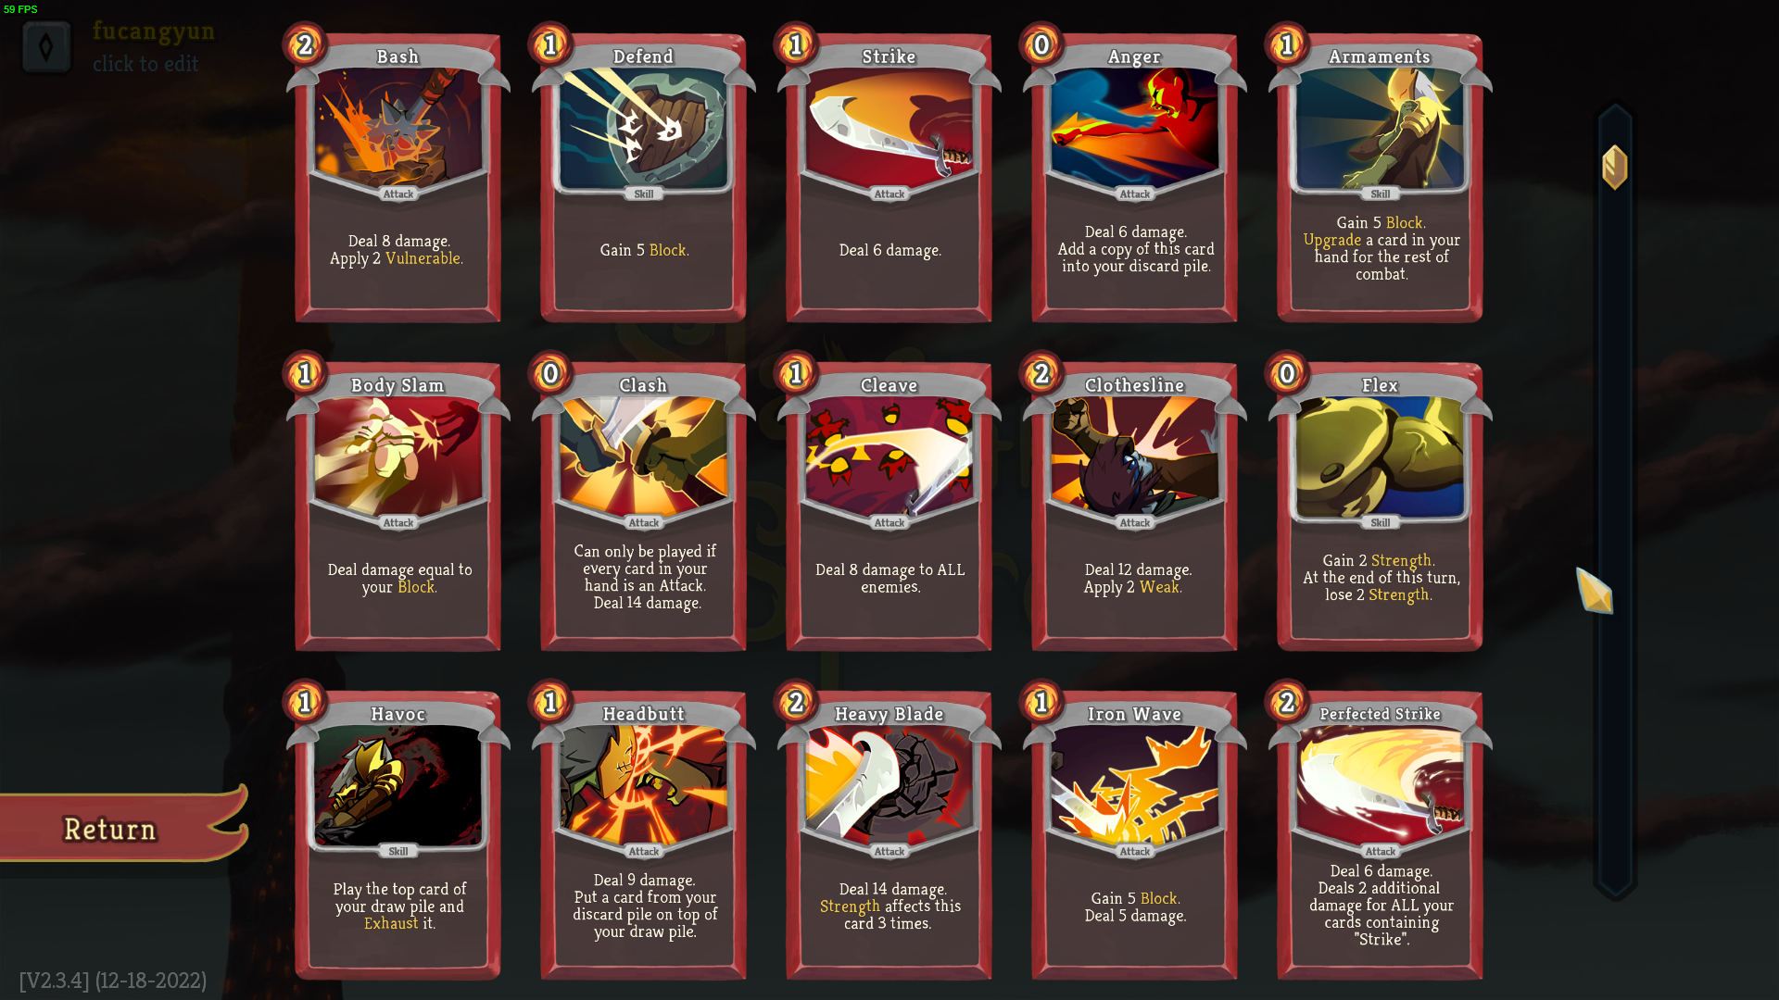

Figure

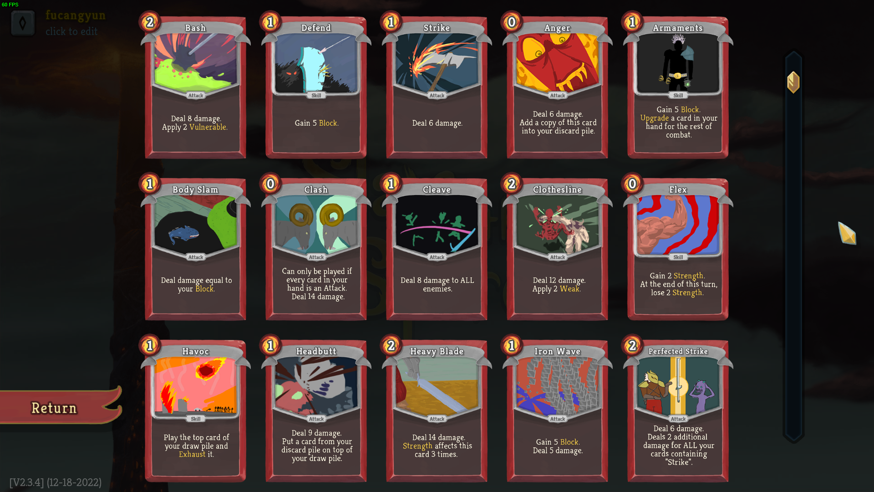

Figure

* The game supports a few practical personalization to determine your own UI and interaction, including but not limited to long-press or click, faster animation, bigger text (Figure 15) and a brand new art style of all cards (after player gets first win with that character) (Figure 16 classic and Figure 17 beta art).
* More choice, more convenient.

# Conclusion

* Slay The Spire does a lot of efforts to reduce the learning cost and create an immersive gaming experience for players, in which the help of UI is indispensable.
* With the help of this easy-to-learn UI, players will have a quicker understanding of game core mechanics and then turn to discover the best way to pass the game much more fast.
* Not only being very friendly to new players, the UI also puts all the useful information in the convenient place for skilled players, which helps them focus on figuring out strategy, instead of wasting time on useless clicking and dragging.